Section 16

Lead Time Analysis

(Processing, Waiting, Queue, Flow, Bottleneck)

OVERVIEW

Selama ini kita fokus melihat kinerja mesin (OEE) dan kinerja operator (OLE & Multitasking). Pertanyaan bisnis berikutnya adalah:

"Kenapa sebuah order selesai lama?"

Untuk menjawab itu, kami membangun Lead Time Analytics dari perspektif Production Order.

Lead Time kami definisikan sebagai:

Lead Time = Queue Time + Processing Time + Waiting Time

Di mana:

Queue Time = waktu order menunggu operasi berikutnya.

Processing Time = waktu yang benar-benar digunakan untuk mengerjakan pekerjaan.

Waiting Time = waktu order berada di mesin tetapi belum menghasilkan nilai tambah (delay internal proses).

Dengan pendekatan ini, kami tidak hanya mengetahui bahwa sebuah order terlambat, tetapi juga dapat menjelaskan penyebab keterlambatannya. Artinya masalah utama bukan kapasitas proses, melainkan antrian antar operasi.

Selain itu, kita juga mulai membangun Machine Flow Analytics, yaitu kemampuan untuk melihat setiap mesin dari sisi:

jumlah order yang diproses,

waktu produktif,

waktu menunggu,

waktu tanpa pekerjaan (No Job),

intensitas antrian,

serta eksposur multitasking operator.

Tujuan akhirnya bukan langsung mencari true bottleneck, tetapi terlebih dahulu mengidentifikasi:

"Mesin mana yang paling berpotensi menjadi penghambat aliran order."

Dengan demikian, analisis tidak lagi berhenti pada pertanyaan: Mesin mana yang performanya rendah? tetapi meningkat menjadi:

Mesin mana yang memperlambat penyelesaian order pelanggan?

Dan itulah fondasi untuk pengelolaan Turn Around Time (TAT), peningkatan flow process, serta identifikasi bottleneck secara lebih objektif.

Definisi
- Definisi:
Lead Time = total waktu dari awal sampai selesai suatu order atau activity confirmation.

Ilustrasi dari perspective mesin/operator

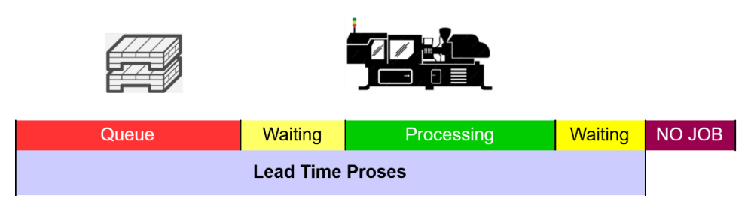

Formula :

Lead Time = Processing + Waiting + Queue Dari satu cycle process

Processing Time = waktu benar‑benar dikerjakan (value added) waktu saat operator/mesin bekerja. Dalam konteks HMI system :

Processing_Minutes = Running_Minutes (1 dan 2) + SmallStop_Minutes (6, 7, 8, 9)

Waiting Time = waktu tidak dikerjakan meskipun komponen (job) sudah di atas mesin.

Queue Time = FirstStart_Time – Arrival_Time hanya bagian awal dari waiting.

Arival_Time = Event_Time terakhir finish activity sebelumnya.

FirstStart_Time = Start_Job

Dalam konteks HMI Event [Login_Job] Then [Start_Job]

Jika diurutkan sesuai flow aktivitas, maka :

Lead Time = Queue (waiting di awal) + Processing + Waiting (internal delay)

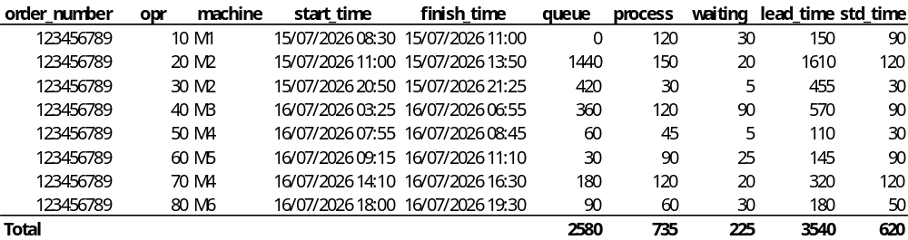

DATA PROCESSING LEAD TIME TIMELINE

UNIFY_5051_LT_TIMELINE

LOAD SOURCE DATA

let Source = UNIFY_5051_TB,

FILTER VALID

Base = Table.SelectRows(Source, each [Time_Bucket] <> null and [Machineid] <> null),

ADD DATE

AddDate = Table.AddColumn(Base,"Date", each Date.From([Time_Bucket]), type date),

ADD LEAD TIME STATE ENGINE

ProductiveStatus = {"1","2","6","7","8","9"},

AddState = Table.AddColumn(AddDate,"LT_State",each

if List.Contains(ProductiveStatus, [statusid]) then "Productive"

else if [statusid] = "4" then "No Job" else "Waiting", type text),

ADD FLAG

IsProductive = Table.AddColumn(AddState,"IsProductive", each if [LT_State]="Productive" then 1 else 0, Int64.Type),

IsNoJob = Table.AddColumn(IsProductive,"IsNoJob", each if [LT_State]="No Job" then 1 else 0, Int64.Type),

IsWaiting = Table.AddColumn(IsNoJob,"IsWaiting", each if [LT_State]="Waiting" then 1 else 0, Int64.Type),

IsActiveOrder = Table.AddColumn(IsWaiting, "IsActiveOrder", each if [conf_number] <> null then 1 else 0, Int64.Type),

IsPostCompletion = Table.AddColumn(IsActiveOrder,"IsPostCompletion",each

if [DateTime_Finish] = null then 0 else if [Time_Bucket] > [DateTime_Finish] then 1 else 0, Int64.Type),

IsActiveLifecycle = Table.AddColumn(IsPostCompletion, "IsActiveLifecycle", each if [DateTime_Finish] = null then null else if [Time_Bucket] <= [DateTime_Finish] then 1 else 0, Int64.Type),

FINAL COLUMN SET

Final = Table.SelectColumns(IsActiveLifecycle,{"Time_Bucket","Date","Machineid","sn_employee",

"order_number","Opr_no","conf_number","statusid","LT_State",

"IsProductive","IsWaiting","IsNoJob", "IsActiveOrder","IsPostCompletion","IsActiveLifecycle"}),

TYPE FIX

FixTypes = Table.TransformColumnTypes(Final,{{"Machineid", type text},{"sn_employee", type text}, {"order_number", type text}, {"Opr_no", type text}, {"conf_number", type text}})

in FixTypes

OUTPUT

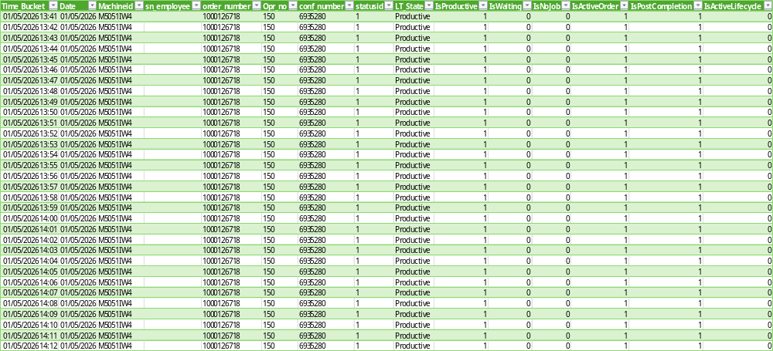

KPI (CORE DATA)

Time_Bucket = Timeline Bucket

Date = Timeline Date

Machineid = Work center Mesin

sn_employee = Operator ID

order_number = Production Order Number

Opr_no = Operation Sequence (SOW / Routing)

conf_number = SAP conf Number

statusid = Mesin status (HMI)

LT_State = Lead Time Status (Productive, Waiting)

IsProductive = Flag Productive

IsWaiting = Flag Waiting

IsNoJob = Flag No Job

IsActiveOrder = Flag Current Job

HITUNG ORDER OPERATION KPI (KPI DARI PERSPECTIVE ORDER)

UNIFY_5051_ORD_OPR_KPI

LOAD SOURCE DATA

let Source = UNIFY_5051_LT_TIMELINE,

FILTER VALID

Base = Table.SelectRows(Source, each [conf_number] <> null and [Time_Bucket] <> null),

OPERATION KPI

OperationKPI = Table.Group(Base, {"conf_number"},

{{"Date", each List.Min([Date]), type date},

{"Machineid", each List.First(List.RemoveNulls([Machineid])), type text},

{"order_number", each List.First(List.RemoveNulls([order_number])), type text},

{"Opr_no", each List.First(List.RemoveNulls([Opr_no])), type text},

{"Productive_Min", each List.Sum([IsProductive]), Int64.Type},

{"Waiting_Min", each List.Sum([IsWaiting]), Int64.Type},

{"NoJob_Min", each List.Sum([IsNoJob]), Int64.Type},

{"Total_Min", each Table.RowCount(_), Int64.Type}})

in

OperationKPI

OUTPUT

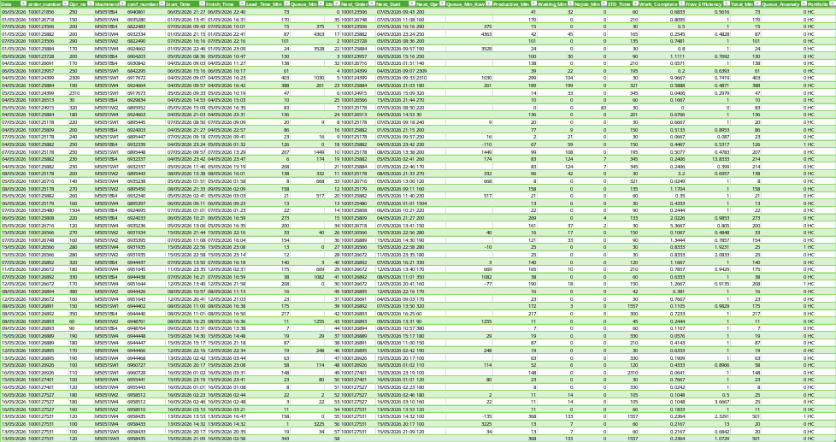

KPI

Date = Record date

order_number = Production Order

Opr_no = sequence operasi (routing / SOW)

Machineid = Work Center Mesin

conf_number = SAP confirmation number

Start_Time = Operation Start

Finish_Time = Operation Finish

Lead_Time_Min = Operation Lead Time

Queue_Min = Waktu antri order-operation

Productive_Min = VA + NNVA

Waiting_Min = Internal delay (all waiting)

NoJob_Min = Machine idle karena tidak ada job (no assignment)

STD_Time = standard time operasi

Work_Complete = Productive minutes / STD time (absorption minutes)

Flow_Efficiency = Productive minutes / Total Minutes

Total_Min = Total minutes yang tercatat di sistem (HMI)

Portfolio = Product type

JOINT LEAD TIME KPI DARI PESPECTIVE ORDER KE MESIN

UNIFY_5051_FACT_ORD_OPR

LOAD SOURCE DATA

let Source = UNIFY_5051_TB,

FILTER VALID

Base =Table.SelectRows(Source, each [Time_Bucket] <> null and [order_number] <> null and [Opr_no] <> null and [Machineid] <> null),

GROUP BY ORDER, OPERATION DAN MESIN

OperationGroup = Table.Group(Base,{"order_number", "Opr_no","Machineid","conf_number"},

{{"Start_Time", each List.Min([Time_Bucket]),type datetime},

{"Finish_Time", each List.Max([Time_Bucket]),type datetime},

{"Lead_Time_Min", each Table.RowCount(_), Int64.Type},

{"STD_Time", each List.Max([STD_time]), Int64.Type},

{"Portfolio", each List.First([Portfolio]),type text}}),

SORT DATA

Sorted = Table.Sort(OperationGroup,{{"order_number", Order.Ascending},{"Start_Time", Order.Ascending}}),

ADD INDEX

AddIndex = Table.AddIndexColumn(Sorted,"Idx",0,1,Int64.Type),

BUFFER DATA (SUPAYA CEPAT)

Buffered = Table.Buffer(AddIndex),

ACTUAL SEQUENCE (OPSIONAL)

AddActualSeq = Table.AddColumn(Buffered, "Actual_Seq",

each List.Count(Table.SelectRows(Buffered,

(r)=> r[order_number]=[order_number] and r[Start_Time] <= [Start_Time])[order_number]), Int64.Type),

CARI OPERASI BERIKUTNYA

NextOrder = Table.AddColumn(Buffered,

"Next_Order", each try Buffered[order_number]{[Idx]+1} otherwise null, type text),

CARI NEXT START OPERASI BERIKUTNYA

NextStart = Table.AddColumn(NextOrder,"Next_Start",each try Buffered[Start_Time]{[Idx]+1} otherwise null, type datetime),

NEXT OPERATION

NextOpr = Table.AddColumn(NextStart,

"Next_Opr", each try Buffered[Opr_no]{[Idx]+1} otherwise null, type text),

HITUNG QUEUE TIME (UNTUK ORDER YANG SAMA)

AddQueueRaw = Table.AddColumn(NextOpr, "Queue_Min_Raw",

each if [order_number] <> [Next_Order] then null

else Duration.TotalMinutes([Next_Start] - [Finish_Time]), Int64.Type),

AddQueue = Table.AddColumn(AddQueueRaw, "Queue_Min",

each if [Queue_Min_Raw] = null then null

else if [Queue_Min_Raw] < 0 then 0

else Number.Round([Queue_Min_Raw],0), Int64.Type),

AddQueueAnomaly = Table.AddColumn(AddQueue, "Queue_Anomaly",

each if [Queue_Min_Raw] <> null and [Queue_Min_Raw] < 0 then 1 else 0, Int64.Type),

LOAD OPERATION KPI

OPR_KPI = UNIFY_5051_ORD_OPR_KPI,

JOIN KPI

JoinKPI = Table.NestedJoin(AddQueueAnomaly, {"conf_number"}, OPR_KPI, {"conf_number"}, "KPI", JoinKind.LeftOuter),

EXPAND KPI

ExpandKPI = Table.ExpandTableColumn(JoinKPI,"KPI",

{"Date","Productive_Min", "Waiting_Min", "NoJob_Min", "Total_Min"}),

ADD WORK COMPLETE

AddWorkComplete = Table.AddColumn(ExpandKPI, "Work_Complete",

each if [STD_Time] = null or [STD_Time] = 0 then null else Number.Round([Productive_Min] / [STD_Time], 4), Percentage.Type),

ADD FLOW EFFICIENCY

AddFlowEfficiency = Table.AddColumn(AddWorkComplete, "Flow_Efficiency",

each if [Lead_Time_Min] = null or [Lead_Time_Min] = 0 then null

else Number.Round([Productive_Min] / [Lead_Time_Min], 4), Percentage.Type),

FINAL

Final = Table.ReorderColumns(AddFlowEfficiency,

{"Date", "order_number", "Opr_no", "Machineid", "conf_number",

"Start_Time", "Finish_Time", "Lead_Time_Min", "Queue_Min",

"Productive_Min", "Waiting_Min", "NoJob_Min", "STD_Time", "Work_Complete", "Flow_Efficiency", "Queue_Anomaly", "Portfolio"})

in

Final

OUTPUT

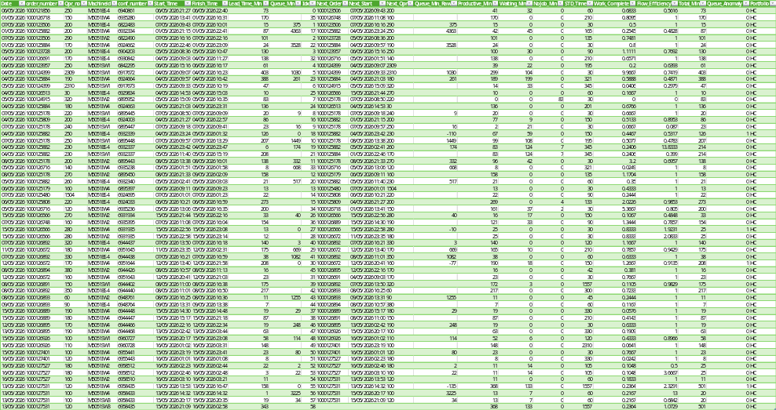

KPI

Date = Record Date

order_number = Production Order

Opr_no = Operation Sequence (SOW / Routing)

Machineid = Work Center Mesin

conf_number = SAP activity confirmation number

Start_Time = Start Operation

Finish_Time = Fnish Operation

Lead_Time_Min = Lead Time

Queue_Min = Antrian

Productive_Min = Productive Minutes

Waiting_Min = Non Productive Minutes – exlude No Job

NoJob_Min = No Job Minutes (No Assignment)

STD_Time = Standard Time Operation

Work_Complete = Productive Minutes / Standard Time

Flow_Efficiency = Productive / Total Minutes

Total_Min = Total Minutes exclude No Job Minutes

Portfolio = Product Type

ORDER LEADTIME ANALYTICS IMPACT

UNIFY_5051_FACT_ORD_LT

LOAD SOURCE DATA

let Source = UNIFY_5051_FACT_ORD_OPR,

GROUP BY ORDER NUMBER

OrderGroup = Table.Group(Source,{"order_number"},

{{"Order_Start", each List.Min([Start_Time]),type datetime},

{"Order_Finish", each List.Max([Finish_Time]), type datetime},

{"Productive_Min", each List.Sum([Productive_Min]), Int64.Type},

{"Waiting_Min", each List.Sum([Waiting_Min]), Int64.Type},

{"NoJob_Min", each List.Sum([NoJob_Min]), Int64.Type},

{"Queue_Min", each List.Sum(List.RemoveNulls([Queue_Min])), Int64.Type},

{"STD_Time", each List.Sum([STD_Time]), Int64.Type},

{"Portfolio", each List.First(List.RemoveNulls([Portfolio])),type text}}),

HITUNG ORDER LEAD TIME

AddLeadTime = Table.AddColumn(OrderGroup,

"Lead_Time_Min", each Duration.TotalMinutes([Order_Finish] - [Order_Start]) + 1,Int64.Type ),

ADD FLOW EFFICIENCY (OPSIONAL BISA DI PBI DAX)

AddFlowEfficiency = Table.AddColumn(AddLeadTime,"Flow_Efficiency",

each if [Lead_Time_Min] = 0 then null

else Number.Round([Productive_Min]/[Lead_Time_Min],4),Percentage.Type),

ADD WORK COMPLETE (OPSIONAL BISA DI PBI DAX)

AddWorkComplete = Table.AddColumn(AddFlowEfficiency,"Work_Complete",

each if [STD_Time] = null or [STD_Time] = 0 then null

else Number.Round([Productive_Min]/[STD_Time],4),Percentage.Type),

ADD DELAY RATIO (OPSIONAL BISA DI PBI DAX)

AddDelayRatio = Table.AddColumn(AddWorkComplete,"Delay_Ratio",

each if [Lead_Time_Min] = 0 then null

else Number.Round([Waiting_Min]/[Lead_Time_Min],4),Percentage.Type),

ADD QUEUE RATIO (OPSIONAL BISA DI PBI DAX)

AddQueueRatio = Table.AddColumn(AddDelayRatio,"Queue_Ratio",

each if [Lead_Time_Min] = 0 then null

else Number.Round([Queue_Min]/[Lead_Time_Min],4),Percentage.Type),

FINAL

Final = Table.ReorderColumns(AddQueueRatio,

{"order_number", "Portfolio", "Order_Start", "Order_Finish", "Lead_Time_Min",

"Productive_Min", "Waiting_Min", "Queue_Min", "NoJob_Min", "Flow_Efficiency", "STD_Time",

"Work_Complete", "Delay_Ratio", "Queue_Ratio"})

in

Finallet Source = UNIFY_5051_FACT_ORD_OPR_FINAL,

OUTPUT

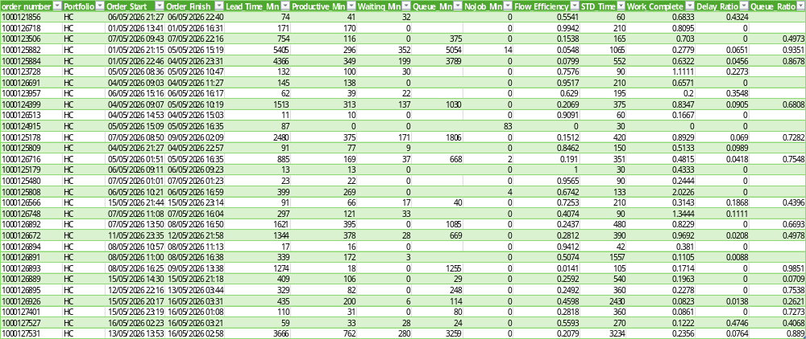

KPI

order_number = Production Order Number

Portfolio = Product Type

Order_Start = Order Start

Order_Finish = Order Finish

Lead_Time_Min = Order Lead Time (Prod Order Lead Time, Internal Process)

Productive_Min = Productive Minutes (VA + NNVA)

Waiting_Min = Internal Delay (All NNVA, Waiting) – Exclude No JOB

Queue_Min = Total Order Queue

NoJob_Min = Total No Job (Optional)

Flow_Efficiency = Productive Minutes / Total Minutes

STD_Time = Standard Time Order (SUM STD_Time Operation)

Work_Complete = Actual Productive / STD_Time Order

Delay_Ratio = Waiting Minutes / Lead Time Minutes

Queue_Ratio = Queue Minutes / Lead Time Minutes

MACHINE FLOW ANALYTICS

UNIFY_5051_FACT_MACHINE_FLOW_DAY

SOURCE

let Source = UNIFY_5051_FACT_ORD_OPR,

GROUP MACHINE DAY

MachineFlow = Table.Group(Source,{"Date", "Machineid"},

{{"Order_Count", each List.Count(List.Distinct(List.RemoveNulls([order_number]))),Int64.Type},

{"Conf_Count", each List.Count(List.Distinct(List.RemoveNulls([conf_number]))), Int64.Type},

{"Productive_Min", each List.Sum([Productive_Min]), Int64.Type},

{"Waiting_Min", each List.Sum([Waiting_Min]), Int64.Type},

{"NoJob_Min", each List.Sum([NoJob_Min]), Int64.Type},

{"Queue_Min", each List.Sum(List.RemoveNulls([Queue_Min])), type number},

{"Avg_Queue_Min", each List.Average(List.RemoveNulls([Queue_Min])), type number},

{"Max_Queue_Min", each List.Max(List.RemoveNulls([Queue_Min])), type number},

{"Queue_Event_Count", each List.Count(List.RemoveNulls([Queue_Min])), Int64.Type},

{"Queue_Anomaly_Count", each List.Sum([Queue_Anomaly]), Int64.Type},

{"Avg_Work_Complete", each List.Average(List.RemoveNulls([Work_Complete])), type number},

{"Avg_Flow_Efficiency", each List.Average(List.RemoveNulls([Flow_Efficiency])),type number}}),

MULTI TASK EXPOSURE

MT_Machine = Table.Group(UNIFY_5051_MT_DTC,{"Date","Machineid"},

{{"MT_Min", each List.Sum([IsMultitask]), Int64.Type},

{"Observed_Min", each Table.RowCount(_), Int64.Type}}),

JOIN MT

JoinMT = Table.NestedJoin(MachineFlow,{"Date","Machineid"}, MT_Machine, {"Date","Machineid"}, "MT", JoinKind.LeftOuter),

//5. EXPAND MT

ExpandMT = Table.ExpandTableColumn(JoinMT, "MT",{"MT_Min", "Observed_Min"}),

HANDLE NULL

FixNullMT = Table.ReplaceValue(ExpandMT, null, 0, Replacer.ReplaceValue,{"MT_Min", "Observed_Min"}), Final = FixNullMT

in Final

OUTPUT

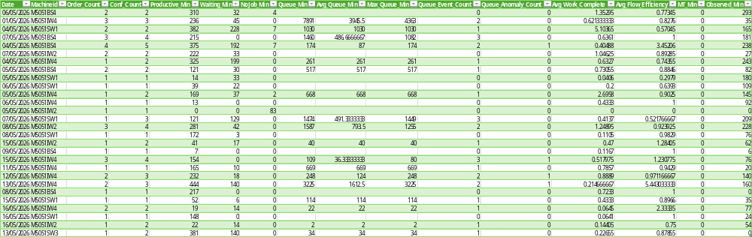

LEAD TIME KPI (EACH MACHINE) DAILY

Date = Record Date

Machineid = Work Center Mesin

Order_Count = Jumlah order yang di load ke mesin

Conf_Count = Jumlah order activity di load ke mesin

Productive_Min = Productive Minutes

Waiting_Min = Waiting Minutes

NoJob_Min = No Job Minutes

Queue_Min = Total antrian di mesin

Avg_Queue_Min = Rata-rata antrian

Max_Queue_Min = Antrian tercepat

Queue_Event_Count = Antrian terlama

Avg_Work_Complete = Productive to STD Time

Avg_Flow_Efficiency = Productive / Total Time

MT_Min = Multi Task exposure minutes

ANALITYCS

MACHINE FLOW

TUJUAN

Mesin mana yang menyebabkan gangguan flow produksi?

Productive Ratio

Productive Ratio = Productive_Minute / Total Minute

Grain: date x machine

Menunjukkan berapa % waktu yang benar-benar produktif.

Visual : Bar Chart (Top 10 machine)

Waiting Ratio

Waiting Ratio = Waiting Minute / Total Minute

Menunjukkan flow loss di level mesin.

Grain: date x machine

Visual : Bar Chart (Top 10 mechine)

Queue Intensity

Queue Intensity = Queue Event / Count Confirmation

Seberapa sering operation mengalami antrian

Visual : Bar Chart (Top 10 Machine)

Queue Per Operation

Queue Per Conf = Queue Minute / Count Confirmation

Seberapa parah (rata-rata) antrian di setiap mesin

Visual : Bar Chart (Top 10 Machine)

Queue Heat Map

Dimensi : Machine x Date x Queue Per Conf

Analytics (Scater Plot)

Dimensi : Queue Per Conf (X) vs Queue Intensity (Y) size Conf_Count

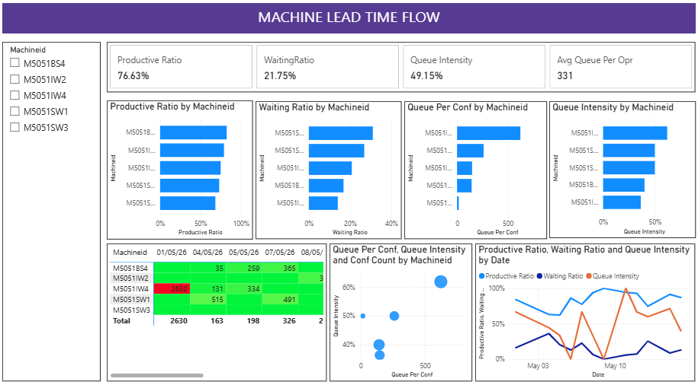

ORDER FLOW

TUJUAN

Apa yang dirasakan (impact) terhadap order/customer?

KPI Cards

Order Average Lead Time

Order Flow Efficiency

Order Queue Ratio

Order Work Complete

Detail (WHERE)

Lead Time by Order Bar Chart

Top Queue Order Bar Chart

Heat Map (WHERE and WHEN)

Portfolio x Date Average Lead Time

ANALYTICS (Scater Plot #1)

Queue Minute vs Lead Time Productive Minute

Menjawab apakah lead time tinggi dikarenakan antrian?

ANALYTICS (Scater Plot #2)

Order Work Complete vs Lead Time Queue Minutes

Lead time tinggi karena pekerjaan besar atau karena flow buruk?

TREND (Multiple Line)

Queue Ratio Trend

Flow Efficiency Trend

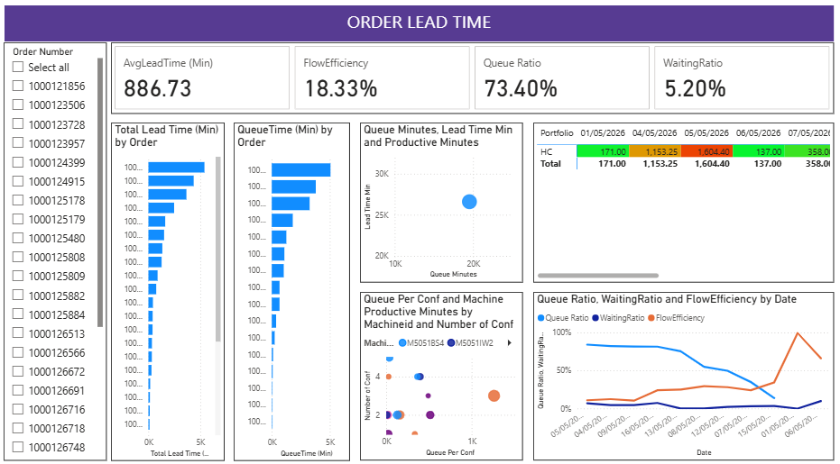

Power BI DAX

MACHINE FLOW LEAD TIME

Measure : Average Work Complete

LT_Machine_AvgWorkComplete = AVERAGE( UNIFY_5051_FACT_MACHINE_FLOW_DAY[Avg_Work_Complete])

Measure : Multitasking Exposure

LT_Machine_MTExposure =

DIVIDE(SUM(UNIFY_5051_FACT_MACHINE_FLOW_DAY[MT_Min]), SUM(UNIFY_5051_FACT_MACHINE_FLOW_DAY[Productive_Min]))

Measure : NoJob Minutes

LT_Machine_No Job Minute = SUM(UNIFY_5051_FACT_MACHINE_FLOW_DAY[NoJob_Min])

Measure : Productive Minutes

LT_Machine_Productive Minute =

SUM(UNIFY_5051_FACT_MACHINE_FLOW_DAY[Productive_Min])

Measure : Queue Intensity

LT_Machine_Queue Intensity =

DIVIDE(SUM(UNIFY_5051_FACT_MACHINE_FLOW_DAY[Queue_Event_Count]),

SUM(UNIFY_5051_FACT_MACHINE_FLOW_DAY[Conf_Count]))

Measure : Queue Per Confirmation

LT_Machine_QueuePerConf = DIVIDE(SUM( UNIFY_5051_FACT_MACHINE_FLOW_DAY[Queue_Min]), SUM(UNIFY_5051_FACT_MACHINE_FLOW_DAY[Conf_Count]))

Measure : Waiting Minutes

LT_Machine_WaitingMinute = SUM(UNIFY_5051_FACT_MACHINE_FLOW_DAY[Waiting_Min])

Measure : Productive Ratio

LT_MachineProductive Ratio = DIVIDE([LT_Machine_Productive Minute], [LT_Machine_WaitingMinute] + [LT_Machine_Productive Minute] + [LT_Machine_No Job Minute])

Measure : Waiting Minutes

LT_MachineWaitingRatio = DIVIDE([LT_Machine_WaitingMinute], [LT_Machine_WaitingMinute] + [LT_Machine_Productive Minute] + [LT_Machine_No Job Minute])

ORDER LEAD TIME

Measure : Order Average Lead Time

LT_ORD_AvgLeadTime (Min) =

DIVIDE(SUM(UNIFY_5051_FACT_ORD_LT[Lead_Time_Min]), DISTINCTCOUNT(UNIFY_5051_FACT_ORD_LT[order_number]))

Measure : Order Lead Time

LT_ORD_TotalLeadTime (Min) = SUM(UNIFY_5051_FACT_ORD_LT[Lead_Time_Min])

Measure : Order Total Productive Minutes

LT_ORD_TotalProductiveTime (Min) = SUM(UNIFY_5051_FACT_ORD_LT[Productive_Min])

Measure : Order Total Queue Minutes

LT_ORD_TotalQueueTime (Min) = SUM(UNIFY_5051_FACT_ORD_LT[Queue_Min])

Measure : Order Total Waiting Minutes

LT_ORD_TotalWaitingTime (Min) = SUM(UNIFY_5051_FACT_ORD_LT[Waiting_Min])

Measure : Order Flow Efficiency

LT_ORD_FlowEfficiency = DIVIDE([LT_ORD_TotalProcessingTime (Min)], [LT_ORD_TotalLeadTime (Min)])

Measure : Order Queue Ratio

LT_ORD_Queue Ratio = DIVIDE(SUM(UNIFY_5051_FACT_ORD_LT[Queue_Min]),

SUM(UNIFY_5051_FACT_ORD_LT[Lead_Time_Min]))

Measure : Order Waiting Ratio

LT_ORD_WaitingRatio = DIVIDE([LT_ORD_TotalWaitingTime (Min)], [LT_ORD_TotalLeadTime (Min)])

